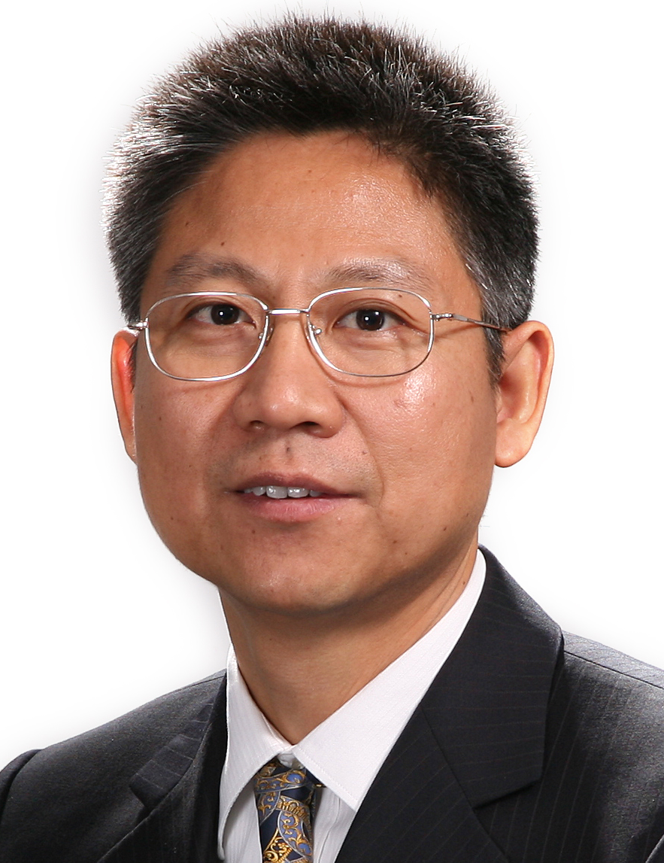
WANG, QIANG (John)
Address | China National Machinery Industry Corporation (SINOMACH)  No.3 Danling Street, Haidian District  Beijing, 100080,  P.R. China
Telephone | +86-10-82688708, +86-13601125287
Fax | +86-10-82688713
Email | johnwangqiang@sina.com, wangqiang@sinomach.com.cn
Nationality/ Date of Birth | Chinese

Educational/Professional Memberships
Ph.D. Candidate, Law School, University of International Business and Economics;
Master of Law, Law School, University of International Business and Economics;
Certificate, Hunan School of Foreign Trade;
Member of the Chartered Institute of Arbitrators (MCIArb);
Listed Arbitrator for the China International Economic and Trade Arbitration Commission (CIETAC), and the Beijing Arbitration Commission (BAC); Singapore International Arbitration Centre (SIAC), Kuala Lumpur Regional Centre for Arbitration (KLRCA), Hong Kong International Arbitration Centre (HKIAC)
Listed Mediator for CCPIT/CCOIC Mediation Centre;
Member of the China Maritime Law Association (CMLA);
Admitted to practice law (qualified lawyer) and registered as an in-house counsel in China;
Senior International Business Engineer
Current Position
General Counsel, China National Machinery Industry Corporation (SINOMACH).
Professional Experience
Started a career in international business since 1985;
Started practicing law as an in-house counsel for a Fortune 500 company since 1995, his area of practice include international mergers and acquisitions, arbitration/litigation, and corporate work, he has advised clients in hundreds of transactions in China and many other countries on such matters as the establishment of joint ventures, tax planning, strategic alliances, mining and resources development, real estate development, construction and engineering, BOT/BOO, intellectual property protection.
Arbitration Experience
Acted as counsel in over 10 arbitration cases, and as sole arbitrator, presiding arbitrator or party-nominated arbitrator since 2001, in over 120 arbitration proceedings (more than 90 cross-border cases) in 11 years, and completed over 80 arbitral awards as presiding/sole arbitrator. This includes CIETAC, BAC, SIAC, ICC and HKIAC, involving international sales of goods, letters of credit, construction projects, ship-building, joint ventures, share transfers, technology transfers, licensing agreements, agency agreements, distribution agreements, processing trade, equipment lease, financial lease, credit insurance, and loan agreements.
Publications
--Succession to and Assumption of Contractual Rights and Obligations in Corporate Mergers and Divisions, International Business Journal, 1999;
--Legal Protection of Minority Shareholders in U.K and U.S.A, International Business Journal, 1999;
--In-House Counsel National Qualification Test Reference Book (Co-author), Economic Science Press, 2010;
Languages
Chinese and English

